Barcelona
CSA Control Library

Gary Bleads

FJ Consulting MAN05

May 2002

Introduction
This document describes the set of utilities that collectively are known as the CSA Control Library.

The CSA Control Library was originally developed as part of the CSA (Customer Services Application) for the Barcelona eCRM system, but is actually much more general purpose, and may useful in many other ASP.NET applications, especially those working with the Barcelona database server.

The CSA Control library consists of a set of ASP.NET custom controls which are used when building web pages. Its purpose is to vastly reduce the amount of HTML and program coding effort needed to produce a set of Internet/Intranet web pages. In most cases a complex web page can be replaced by one line of HTML, an XML configuration file and a .Net resource file.

SharedUtils
The CSA control library can be used free-standing, but if working with the Barcelona database server, features of the optional toolkit class ‘SharedUtils’ will greatly simplify coding. SharedUtils comprises a set of utilities designed to make interaction with the CRM Server very much easier. It contains functions to construct the XML strings that the CRM Server uses to create, modify and delete data. Please see document ??? for a detailed description of the SharedUtils toolkit.

CSA Description
Before getting into the details of the CSA Control library, it is probably a good idea to look at the CSA itself.

The CSA is an intranet based web application, used by helpdesk staff to access and update a customer’s details. All data is held in a centralised database. Access to these databases is through a .Net Web Service, known as the CRM Server. The design of the CRM Server is beyond the scope of this document, and is described in reference ???.

Whilst examining the source code of an existing (REI) customer services application, it became apparent that an awful lot of custom code had been written to perform very similar tasks. There were 75 screens, each requiring an average of 1000 lines of HTML and Java, mixed together in the same JSP page. Most pages also needed large and complex XSLT transformation style sheets to form the CRM Server’s request and display the CRM Server’s result as HTML. The JSP pages were difficult to write and even more difficult to maintain.

The .Net implementation of the CSA uses a similar architecture to the REI CSA, but is based around Microsoft’s .NET framework. Users can access the CSA using a standard web-browser over the client’s intranet. CSA.Net provides a simple to use GUI to the CRM Database, allowing help-desk staff to access and maintain data in the CRM Server. It performs some simple validation of input data, but it does not provide any of the “business” logic, which should be handled by the CRM Database Server.

When a member of the helpdesk staff edits a customer’s details, a string of XML is generated containing details of the changes. This XML message is sent to the CRM server using SOAP over HTTP. The CRM Server processes the request, accesses the database, applies any special business rules, and returns the result back to CSA.NET as another XML message.

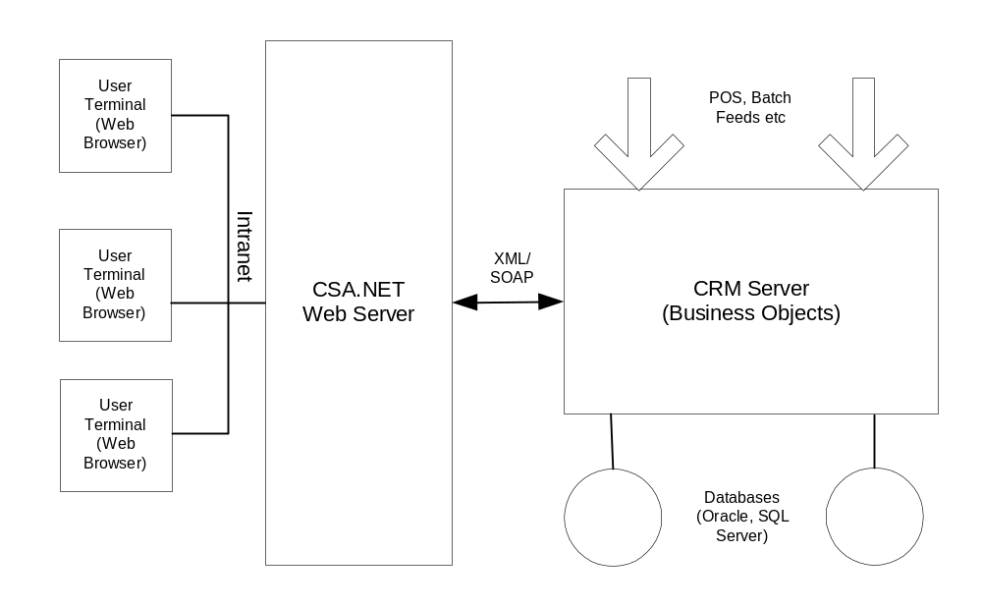
Figure 1 - Solution Overview

CSA Control Library

Examining the existing REI CSA shows that although there are over 70 screens, most of them use a small number of very similar layouts.

To avoid the need to code each screen in HTML and ASP (a rather tedious and error prone business) we have produced a set of ASP.NET custom controls, one for each main layout type. These custom controls display all the required fields and populate them with the relevant customer’s details, and allow updates to be sent to the CRM server.

The page designer controls what information appears on the page by supplying each control with an XML configuration file. The custom controls read their XML configuration file and send to the browser a string of HTML, based on the configuration file’s contents. This is done each time the page is requested.
Most pages contain more than one control, for example, a search screen may have a menu bar at the top, a data-entry form in the middle to allow search criteria to be entered and a Data Table to show the results of the search.

The CSA Control Library currently comprises of the following four controls:
- Menu Bar – Displays the navigation menu at the top of each page
- Data Table – Displays a list of similar items, such as a list of customer’s transactions.
- Data Entry Form – Allows the user to view and update a customer’s details
- Pop-Up – A small “dialogue box” style data-entry form, which allows the user to change a single item of data (i.e. telephone number or email address)

Using the custom control library greatly reduces or completely removes the need to write new HTML and program code, with a corresponding reduction in development time and number of errors. It also ensures that all pages have a similar “look and feel”.

Menu Bar

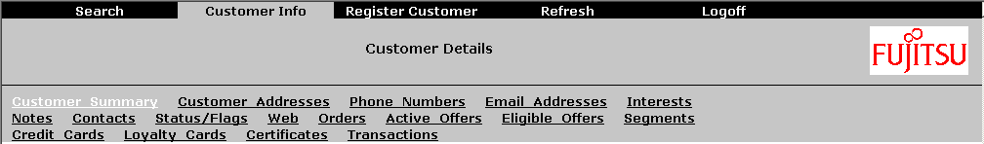

The menu bar appears at the top of every page. It consists of one or two levels of menu hierarchy and a bar in the centre for the title and logo. The colour scheme is defined in the application’s html stylesheet.

The control loads an Xml steering file to get the details of every item in the menu. It generates the html required to display the menu at run-time.

When a menu option is selected, the browser jumps to the URL specified in the relevant section of the steering file.

The following snippet of HTML is all that is needed to display the menu bar shown above:

<ICLCSA:MENU
XMLFilename=”configfiles/menu.xml”
Logo = “small_fj_logo.gif”
caption=”Customer Details”
id=”menu1”
runat=”server”/>

The XMLFilename attribute specifies the name of an XML steering file that defines the contents of the menu. As the user navigates from page to page the appropriate section of the menu steering file is automatically displayed.

The example below shows part of the XML steering file (menu.xml) used to display the menu above.

<?xml version="1.0" encoding="utf-8" ?>
<Menu>
<MenuItem>
<Name>Search</Name>
<Info>Customer Search</Info>
<ShowIfExists>UserID</ShowIfExists>
<URL>customersearch.aspx</URL>
</MenuItem>
<MenuItem>
<Name>Customer Info</Name>
<Info>Displays a Customers Details</Info>
<ShowIfExists>customerXmlDoc</ShowIfExists>
<URL>custdetails.aspx</URL>
<SubmenuItem>
<Name>Customer_Summary</Name>
<URL>custdetails.aspx</URL>
</SubmenuItem>
<SubmenuItem>
<Name>Customer_Addresses</Name>
<URL>custaddress.aspx</URL>
</SubmenuItem>
<SubmenuItem>
<Name>Phone_Numbers</Name>
<URL>custphone.aspx</URL>
</SubmenuItem>
….. ETC….
</MenuItem>
… .ETC….
</Menu>

The ShowIfExists and HideIfExists elements allow individual sections of the menu to be conditionally hidden by testing for the presence or absence of session variables. This allows some menu options to be hidden, depending on the user’s permissions, whether or not a customer’s details is currently loaded etc.

Appendix 1 describes the format of the Menu Steering File.

Data Form

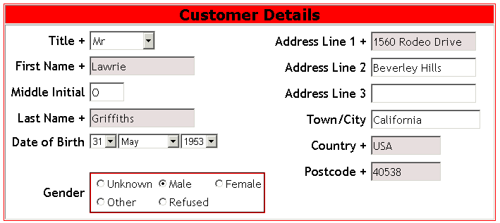

The data form displays information retrieved from the database and allows the user to enter new data and edit existing data.

Data fields may be specified as:-

- Text Boxes (i.e. First Name, Last Name) in the example above.
- Drop Down Lists (i.e. Title), populated from the CRM database server or literal values
- Groups of Radio Buttons
- Dates

Data can be read-only or editable.

Validation rules may be specified to ensure that the parameter has been supplied and that it is within a specified range. Mandatory fields are shown with a “+” and with the text box a different colour.

To display existing information, the entire XML data, as returned from the CRM Server should be supplied to the control. The control will select the relevant parts of the data and display it in the appropriate format.

The following line of HTML displays the data form shown at the start of this section:

<ICLCSA:DataForm
id="DataForm1"
runat="server"
ConfigFile="configfiles/CustomerSearch.xml"/>

The ConfigFile specifies the fields to appear in the form, and is shown in full below:

<?xml version="1.0" encoding="utf-8" ?>
<form>
<header>Customer Details</header>
<column>
<field xpath="//title" type="listbox" default="Mr"
required="true">
<options>
<referencedata domain="title" view="title"
textfield="title/title" valuefield="title/title"/>
</options>
</field>
<field xpath="//first_name" size="150" maxlength="40" required="true"/>
<field xpath="//mi" caption="Middle Initial" size="50" maxlength="10"/>
<field xpath="//last_name" size="150" maxlength="40" required="true"/>
<field xpath="dob" type="date" caption="Date of Birth"
minvalue="01/MAR/1850" maxvalue="Today" default="01/JAN/1900" />
<field type="blankline" />
<field xpath="//unique_info/gender" type="radiobuttons" default="Male">
<options>
<option>Unknown</option>
<option>Male</option>
<option>Female</option>
<option>Other</option>
<option>Refused</option>
</options>
</field>
</column>
<column>
<field xpath="address_line_1" required="true"
size="150" maxlength="80" />
<field xpath="address_line_2" size="150" />
<field xpath="address_line_3" size="150" />
<field xpath="city" caption="Town/City" />
<field xpath="country" size="100" default="UK" required="true" />
<field xpath="post_code" size="100" caption="Postcode"
required="true" />
</column>
</form>

Loading Data

Before any existing data can be displayed in a form, it must be loaded into the dataform control using the attribute ‘XmlDoc’. XmlDoc must be supplied with an XML Document containing the entire customer’s record. The XML string returned from the Barcelona Database server must be converted into an Xml Document before it can be loaded into a CSAControllibrary control. The example below retrieves a customers entire data from the CRM Server, contructs

string sXml;
string strResXml;
XmlDocument xmlDoc = new XmlDocument();

‘ Create a connection to the CRM database Server
csa.CRMServer.XmlGeneric CRMSvr =
new csa.CRMServer.XmlGeneric();
CRMSvr.Url = ConfigurationSettings.AppSettings["CRMServerURL"];

‘ Retrieve a customer’s entire details from the database server as an Xml String
CRMSvr.Get("","customer","customer", crmid,
out strResXml, out sXml))

‘ Create an Xml Dom Document from the customer’s Xml String xmlDoc.LoadXml(sXml);

‘ Load the Xml Document into the Data Form Custom Control
DataForm1.XmlDoc = xmlDoc;

There are cases where the XML may contain more than one instance of the required item. For example, a customer may have multiple addresses and phone numbers. By default, the data form will show the first set of details it finds. If you wish to select a specific instance, the control can be supplied with an XPath string to restrict it to a subsection of the XML data.

The control may be supplied with an xpath statement, hard-coded as an attribute of the dataform in the HTML, or, more commonly, set by the program code behind the html. The c# example below uses a unique crmid to select a single address.

DataForm1.xpath=
@”//address[@address_crmid=1234567_892345_67890ABCDEF]”;

Retrieving Data

All data in a form can be retrieved using the function GetDataValues. This returns a hash table (A collection of name/value pairs) containing the names and value of each field in the form.

The data values can be extracted from the hashtable and used individually, or the entire hashtable can be passed to the SharedUtils toolkit, which will convert it into XML for sending to the CRM Server (See ref ??? for a description of SharedUtils)

The function below shows a sample of code from the Logon web page. It is executed when the Login button on the web page is pressed. It retrieves all of the data values entered into DataForm1 and stores the contents of the ‘user_name’ field in the session variable ‘UserId’.

private void Button1_Click(object sender, System.EventArgs e)
{
Hashtable ht = DataForm1.GetDataValues();

Session["UserID"] = ht["user_name"];
Response.Redirect(_homePage);
}

Data Tables

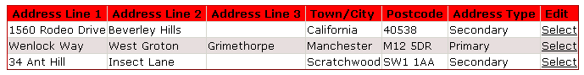

Data Tables are used to display multiple items of data in tabular form, such as the results from a search or a list of a customer’s transactions. Each line may have a hyperlink to a detailed view or an edit page.

Like the data form, the table is populated automatically from the customer detail XML.

The following snippet of HTML displays the table above:

<ICLCSA:DataTable
id="DataTable1"
runat="server"
ConfigFile="configfiles/custaddress.xml"/>

The XML configuration file to display the example is shown below:

<?xml version="1.0" encoding="utf-8" ?>
<table xpath="address">
<field xpath="address_line_1" />
<field xpath="address_line_2" />
<field xpath="address_line_3" />
<field xpath="city" caption="Town/City" />
<field xpath="post_code" caption="Postcode" sortorder="1" />
<field xpath="address_type" />
<field caption="Edit"
type="select"
xpath="address/@address_crmid"
href="custaddress.aspx?address_crmid={0}" />
</table>

Popup Forms

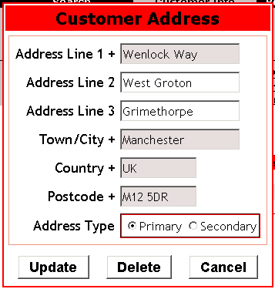

These look like a small pop-up window containing a form with a few items to enter or edit. Buttons at the bottom of the form allow the record to be updated or deleted. A Cancel button closes the form. Although it looks like a separate window, it’s actually a new layer on top of the main web page, but is designed to look like a pop-up dialogue box.

Popup forms are very similar to a normal data-entry forms, but with the addition of one or more buttons at the bottom. The XML for this form is identical to the data-entry form.

The Popup form can be made to “pop up” by adding a C# statement into code behind the ASPX page, i.e:

Popup1.ShowForUpdateDelete();

When a button is pressed, the popup form will disappear and an event (onInsertClick, onUpdateClick, onDeleteClick, onCancelClick) will be raised. The web page designer should provide event handlers to handle these button clicks.

Using the CSA Control Library

The best way of learning how to use the CSA control library is to examine one of the existing web applications that make use of it. Before trying to use the CSA control library, you should have a basic understanding of the SharedUtils toolkit and of the Barcelona Server.

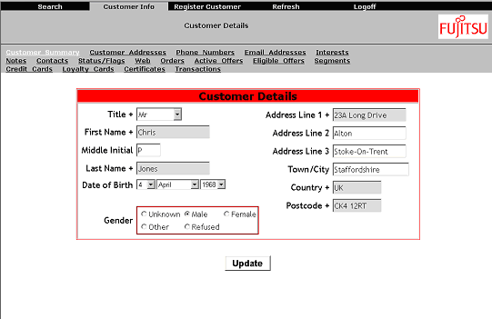

This section will describe the steps required to create a typical HTML page (see above) using the CSA Control Library. The page will have a menu bar at the top and a form to display a customer’s details. Pressing the update button will send any changes to the Barcelona database server.

- Add the following line to the top of the HTML page to load the CSA Control library:
<%@ Register TagPrefix=”FJCSA” Namespace=”Fujitsu.eCrm.CSAControlLibrary
Assembly=”CSAControlLibrary” %>
- Add a menu at the top of the page with the following HTML:

<FJCSA:Menu
runat=”server”
id=”menu1”
logo=”images/small_fj_logo.gif”,
xmlFilename=”configfiles/menu.xml” />

Create the menu steering file menu.xml in the subdirectory configfiles. (See the steering file example in the Menu Section earlier in this document)
- Add a data-entry form with the following HTML:
<FJCSA:DataForm
runat=”server”
id=”DataForm1”
ConfigFile=”configfiles/nameaddress.xml” />

Create a config file for the data-entry form, similar to the example in the dataform section of this document.

- Add an Update button to the page with the following HTML:
<asp:Button id=”Button1” runat=”server” text=”Update” \>
- In the Page_Load section of the C# code-behind file, add code to initialise the data form with the customer’s details. The code required to do this will vary according to the application but may look something like the following:-
private void Page_Load(object sender, System.EventArgs e)
{
if (!Page.IsPostBack)
{
XmlDocument xmlDoc = getCustomerDetails();
DataForm1.XmlDoc = xmlDoc;
}
}

- In the C# file, add code to the update button’s click event to write the new data to the CRM server database. For information about templates, please see the SharedUtils documentation.

private void Button1_Click(object sender, System.EventArgs e)
{

// load the template
XmlTemplate template =
newXmlTemplate(Server.MapPath(@"templates\customer.xml"));

// get the customer's original details
XmlDocument customerXmlDoc = null;
customerXmlDoc = (XmlDocument)Session["customerXmlDoc"];

// update the customer details by merging in the new values
template.UpdateSubElement(customerXmlDoc,
DataForm1.GetDataValues());

// Store the new details on the CRM database server
csa.CRMServer.XmlGeneric CRMSvr =
new csa.CRMServer.XmlGeneric();
CRMSvr.Set("","customer","customer", template.GetXmlString())

}

In most cases, these steps may be combined into a single ASP user control that can be reused throughout the application. For an example of this, see formpanel.ascx in the CSA application.

Appendix A: Menu Reference

Menu Attributes
The following attributes are understood by the menu customer control. The parameters may be supplied in the HTML or from the associated C# or VB code behind the web page.

Parameter | Type | Description | Required
XmlFilename | string | The relative path of the XML Steering file. See Appendix 2 | Mandatory
Caption | string | The page title to appear in the menu bar. | Optional
logo | string | The relative path of a GIF or JPG file containing the logo to appear in the menu bar. | Optional. If not supplied, the “Info” field from the steering file will be used.

To set the parameters in HTML, supply them as attributes to the HTML tag, for instance,

<ICLCSA:Menu
runat=”server”
id=”menu1”
logo=”images/small_logo.gif”
Caption=”customer details”
XmlFilename=”configfiles/menu.xml” />

Alternatively, you can supply the parameters from the C# or VB code associated with the page. This is particularly useful for multilingual purposes, where a different steering file can be used for each language.

For instance, the following snippet of C# code could be used in the Page_Load method to load the values of the parameters from a resource file:

menu1.Caption = _resource.GetString("menu1.Caption");
menu1.logo = _resource.GetString("menu1.logo");
menu1.XmlFilename = _resource.GetString("menu1.XmlFilename");

Menu Steering File Format

Element | Description
Menu | Top Level Element. Required
MenuItem | One required for each Top-Level menu item.
Name | Menu Text, as it appears on the menu “tab”. Required.
Info | Descriptive text, appears if menu item is active. Optional.
ShowIfExists | The menuItem will only appear if the session variable name in this element is declared, e.g.  <ShowIfExists>UserID</ShowIfExists> will cause the menu item to appear only if the ASP Session Variable ‘UserID’ is not null. This element is optional. If omitted, the menu item is always shown.
HideIfExists | The menuItem will only appear if the session variable name in this element is not declared, e.g.  <ShowIfExists>UserID</ShowIfExists> will cause the menu item to appear only if the ASP Session Variable ‘UserID’ is null. This element is optional. If omitted, the menu item is always shown.
URL | The URL of the page to be shown if this menu item is selected. Required.
SubmenuItem | One or more sub-menu elements that will be shown if the top-level element is selected.
Name | Sub-menu hyperlink Text. Required
URL | The URL of the page to be shown if this sub-menu item is selected. Required.
NewLine | (ATTRIBUTE) If supplied as an attribute to the submenuItem element, any following submenuItems will appear on the next line. Optional. The attribute value is ignored.  i.e. <SubmenuItem newline=”true”>

Appendix B: Data Form Attributes & Methods

Data Form Attributes
The following attributes are understood by the Data Form customer control. The parameters may be supplied in the HTML or from the associated C# or VB code behind the web page.

Parameter | Type | Description | Required
ReadOnly | bool | Sets the entire form to read-only mode. Useful when displaying values that are not to be edited. | Optional. Defaults to False if not supplied.
ConfigFile | string | The relative path name of the XML steering file. | Mandatory
XmlDoc | XmlDocument | Load data into the form. Normally set to an XmlDocument containing a customer’s entire record. | Optional. If not supplied, all fields of the form will initially be empty.
XPath | string | Selects a subsection of the XmlDoc | Optional. If not specified, the entire XmlDoc will be used.

Data Form Methods

public Hashtable GetDataValues()

Returns a Hash Table containing a list of name/value pairs, populated with the contents of each field in the form. All data is held as strings, with dates in the format ‘yyyy-MM-dd’, i.e. ‘2002-02-26’.

Appendix C: Popup Form Reference

Popup Attributes

Popup forms have the same attributes as data forms. Please see Appendix B for further details.

Popup Methods

public Hashtable GetDataValues()

Returns a Hash Table containing a list of name/value pairs, populated with the contents of each field in the form. All data is held as strings, with dates in the format ‘yyyy-MM-dd’, i.e. ‘2002-02-26’.

public void ShowForViewing()
public void ShowForInsert()
public void ShowForUpdate()
public void ShowForUpdateDelete()
public void ShowForDelete()

The ShowFor… methods cause the popup to appear on the screen, in the specified mode. The only difference between the modes is which buttons are visible.

Popup Properties

public bool ShowCancel
public bool ShowInsert
public bool ShowUpdate
public bool ShowDelete

These allow manual control over which buttons appear on the form. They are normally selected automatically by the ShowFor… methods. If selected manually, set Visible=true to make the popup appear on-screen.

Popup Events

public event EventHandler InsertClick;
public event EventHandler UpdateClick;
public event EventHandler DeleteClick;
public event EventHandler CancelClick;

One of the click events is raised whenever the Insert, Update, Delete or Cancel button is pressed on the popup form.

Appendix 5: Data Form and Popup Steering Files

These steering files apply equally to data forms and popup forms.

A form or popup form comprises of a number of data entry fields, arranged in one or two columns. The fields within each column should be in an <column></column> pair of tags, e.g.

<?xml version="1.0" encoding="utf-8" ?>
<form>
<header>Customer Details</header>
<column>
… fields in column 1 …
</column>
<column>
… fields in column 2 …
</column>
</form>

If there is only a single column, a single <column></column> tag should still be used.

Each column may contain one or more of the following field types:-

textbox :
Displays a text entry field allowing data to be viewed, entered and updated. If the control type is not specified, it will be displayed as a textbox.

currency :
Like textbox, but formats numeric values in a fixed point format, i.e. 3.5 will be displayed as 3.50

listbox :
Displays a drop-down list containing a number of pre-defined values. Only one value can be selected. The listbox contents may be loaded from the CRMServer or specified in the config xml.

radiobuttons
Similar function to a listbox in that it allows one of a number of pre-defined values to be selected. The buttons may be loaded from the CRMServer or specified in the config xml.

date
Displays a set of drop-down lists containing day,month, year, allowing the user to select a date

startdate
Similar to date, but does not display the day of the month. The day is always forced to be 1. This is useful for credit card start dates etc.

Enddate
Similar to date, but does not display the day of the month. The day is always forced to be the last day of the selected month. This is useful for credit card end dates etc.

blankline
Adds a blank line, useful for visually separating sections of the form.

Each of the fields has a number of parameters. The parameters allows varies according to the control type:-

textbox | Xpath, caption, maxlength, size, height, default, mode, required, regularexpression, maxvalue, minvalue, datatype, readonly
currency | Xpath, caption, maxlength, size, height, default, mode, required, readonly, maxvalue, minvalue, datatype, regularexpression
listbox | Xpath, caption, readonly, required
radiobuttons | Xpath, caption, readonly, required
Date | Xpath, caption, required, maxvalue, minvalue
startdate | Xpath, caption, required, maxvalue, minvalue
enddate | Xpath, caption, required, maxvalue, minvalue
blankline

Parameter Descriptions

default
The initial value to be used if the field does not contain data from the database. For date values, this may be a date, such as “01/JAN/1900” or the keyword “TODAY”. Alternatively, the contents of a session variable may be used by preceding the session variable name by the character “$”, for example, default=”$userId”. Optional.

caption
The text to be displayed alongside the data entry field. This field is optional. If not supplied, the caption will be generated from the name of the data item being displayed.

xpath
An xpath expression describing the location of the required data item within the CRMServer XML. This may be a complex xpath expression, or may just contain the name of the field required, in which case the first element found with that name will be used. This parameter is required if the control is to display information from the database.

Normally the CSAControl library will automatically bind the field to the appropriate place in the Customers XML Data, and will display an error message if it is unable to do so. The automatic data binding can be stopped by preceding the xpath with the underscore character “_”. This allows data to be processed by the web page instead of the database. An example of this might be to allow the web page to validate a password without storing it in the database.

Examples:
"address_line_1" – displays the first address_line_1 found.
“//unique_info/gender” – displays the gender field within the first “unique_info” element.
“phone/@phone_crmid” - Displays the contents of the “phone_crmid attribute.

mode
Used with text boxes. Options are “password” (all characters are displayed as “*” or “multiline” (The text is allowed to span multiple lines). If any other value is supplied, or the attribute is omitted, the text is displayed as a normal single line

size
The width of the control in pixels. Optional.

height
The height of the control in pixels. Only useful with multi-line textboxes. Optional.

maxlength
The maximum number of characters that may be entered into a textbox. Optional.

required
Indicates that the field is mandatory, and that a value must be supplied. i.e. required=”true”. If the user does not enter a value into a required field, an error message will be displayed. Optional.

minvalue
The smallest value that is allowed. If the user enters a data value less than this, it will be rejected. May be numeric or a date, depending upon the datatype parameter. For date values, this may be a date, such as “01/JAN/1900” or the keyword “TODAY”. Optional

maxvalue
The maximum value that is allowed. If the user enters a data value greater than this, it will be rejected. May be numeric or a date, depending upon the datatype parameter. For date values, this may be a date, such as “01/JAN/1900” or the keyword “TODAY”. Optional

datatype
Specifies the type of validation to be performed using the minvalue and maxvalue parameters. Options are “integer”, “date”, “double”, “currency” and “string”. If omitted, and a min or max value is specified, the data is assumed to be integer. If the data is not of the expected type (i.e. a date is supplied when an integer is expected), the form will be rejected.

regularexpression
Specifies a perl style regular expression that the data is checked against. Useful to ensure that credit card numbers & email addresses have been entered in the correct format. i.e. regularexpression=”.*@.*\..*” will ensure that a valid email address has been entered.

List Contents
In addition, the listbox and radiobutton controls should be supplied with a set of possible values. These may either be fixed values, supplied in the xml steering file, or can be loaded from a CRMServer view.

Fixed Value Lists
Fixed values should be supplied in the XML steering file, see the example below:

<field xpath="//unique_info/gender"
type="radiobuttons"
default="Male">
<options>
<option ref=”U” >Unknown</option>
<option ref=”M” >Male</option>
<option ref=”F”>Female</option>
<option ref=”O”>Other</option>
</options>
</field>

The “ref” attribute specifies the value that will be stored in the database. If “ref” is not supplied, the text value will be written to the database instead.
The default value may be either the Text value or the Ref value, i.e. default=”Male” and default=”M” will both work.

Data Bound Lists
In this case, the list box is automatically populated from the contents of the CRM server database. When using data bound lists, it is necessary to specify the domain and view of the information to be retrieved from the database and the xpaths of the data to be used for the display text and reference values.

<field xpath="customer_interest/interest_crmid"
caption="Interest Description"
type="listbox"
required="true">
<options>
<referencedata domain="interest"
view="interest"
restricted=”false”
textfield="interest/interest_description"
valuefield=”interest/@interest_crmid” />
</options>
</field>

When it is set to True, the restricted attribute instructs the list to only display items that are valid for the current customer. For example, it is possible to restrict the list to only display offers that the current customer is eligible for. For this to work, the session variable “customer_crmid” must be set to the current customer’s ID.

Appendix 6 : Data Table Steering File Format

The Data Table steering files should be in the format of the example below:

<?xml version="1.0" encoding="utf-8" ?>
<table xpath="txn_detail">
<field xpath="item_quantity" caption="Qty" type="integer" />
<field xpath="txn_product_id" caption="Product ID" sortorder="2" />
<field xpath="txn_product_description" caption="Description" />
<field xpath="txn_department_description" caption="Department" sortorder="1" />
<field xpath="item_amount" caption="Amount" type="currency" />
<field xpath="discount_amount" type="currency" caption="Discount" />
</table>

The xpath attribute of the table element specifies which part of the customer Xml record to populate the table from.

Each column in the table should be specified by a <field> element. The field element has a number of additional parameters which allow control over how the displayed.

xpath
The name of the data item to be displayed in this field. Must be supplied.

caption
The column title to be displayed in the table header. Optional, if omitted, a caption will be automatically generated from the xpath.

type
Allows the format in which the data is displayed to be specified and the sorting algorithm. If not specified, data is displayed as left-aligned with no special formatting. Other options are:

TYPE | ALIGNMENT | SORT TYPE | EXAMPLE FORMAT
(not supplied) | Left | alphanumeric | Peter Jones
date | Center | date | 25/Jan/2002
startdate | Center | date | 01/May/1950
enddate | Center | date | 31/Dec/2004
currency | Right | numeric | 12.50
integer | Right | numeric | 12
double | Right | numeric | 12.5
select | Center | n/a | select

href
Used with the ‘select’ type, specifies the URL of a page which is navigated to when the ‘select’ hyperlink is clicked. If href contains ‘{0}’, this will be replaced by the CRM ID of the selected item.

<field
type="select"
caption="View Details"
xpath=txn/@txn_crmid href="transdetail.aspx?txn_crmid={0}" />

sortorder
Allows the table to be displayed sorted on one or more fields. A number supplied with the sortorder specifies the priority if sorting on more than one field. The field with the lowest number has the highest priority.

<?xml version="1.0" encoding="utf-8" ?>
<table xpath="customer">
<field xpath="first_name" sortorder="2" />
<field xpath="mi" caption="Initials" sortorder="3"/>
<field xpath="last_name" sortorder="1" />
</table>

sortreverse
Similar to sortorder, but sorts the field in descending order. sortreverse fields may be used in the same table as sortorder ones, as long as the priority numbers are different.

Appendix 7 : Session Variables

Session variables are used for various purposes by the CSAControl Library.
.

Menu Control
The menu control uses session variables to control whether or not to hide certain menu options. See the “ShowIfExists” and “HideIfExists” parameters in Appendix 2.

Data Form and Popup Form
The following session variables are used by the Data Form and Popup Form custom controls.

language
The language session variable is required when creating multilingual applications. The only language currently recognised is ‘French’. All other values are treated as the default, English. This is needed when handling dates and to ensure the correct steering file is loaded for the current language. e.g.

Session[“language”] = “French”;

customer_crmid
This is used only when displaying restricted CRMServer data in dropdown lists and arrays of buttons. See the Data Bound Lists section of appendix 5.

Session["customer_crmid"] = cust_crmid;

Default Values
It is possible to specify that the default value for any field. This can be specified in the steering file as either a fixed value, i.e. default=”Help Desk” or as the contents of a session variable, i.e. default=”$UserId”.

